Steps to Access ‘App’ Interface
- Download ‘Bluefy’ on iOS App Store
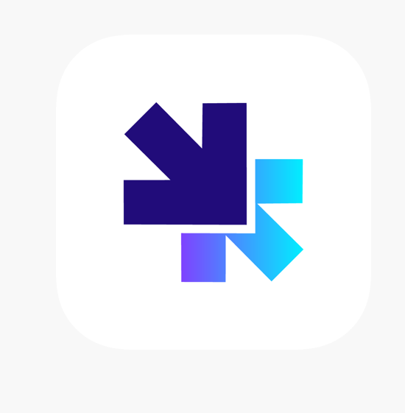
- Enter hhtps://www.theonlywgt.com into the search bar.
- Ensure you reach the Connect to MCU page
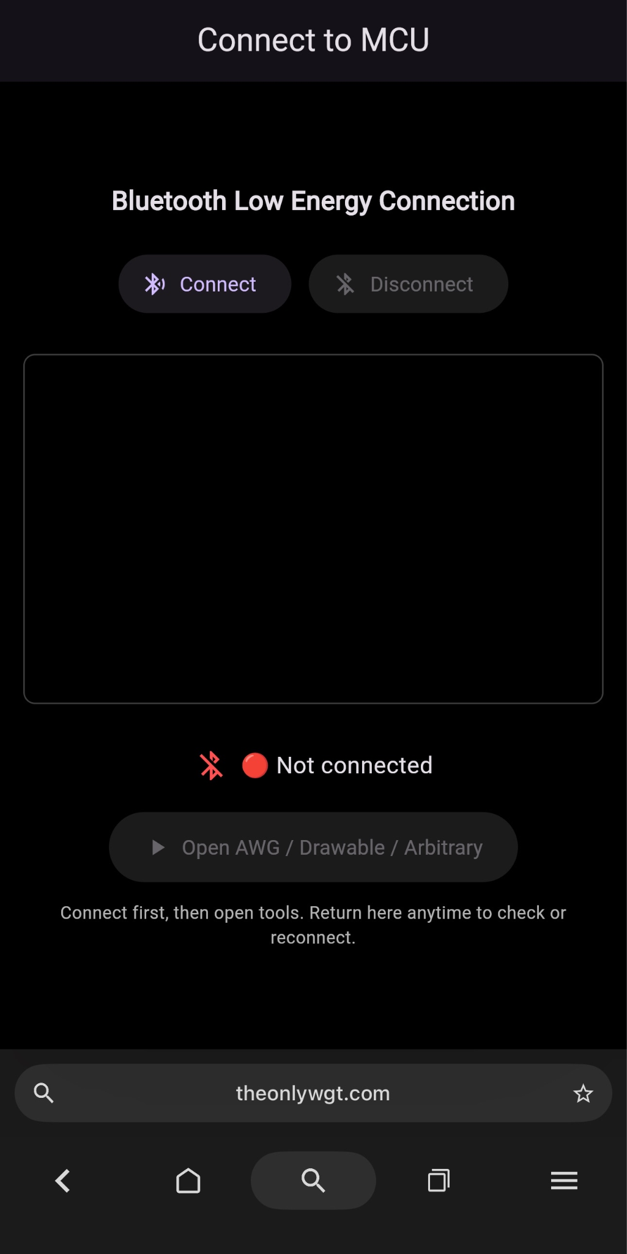
- Power ESP32 and flash Arduino code. The current code to do this is saved as blu_test.ino
- Click ‘Connect’ on the app and select the ESP32. Wait for the connection indicator to turn green.
  - Tip: Send a test message using the Payload text line. Send using RX
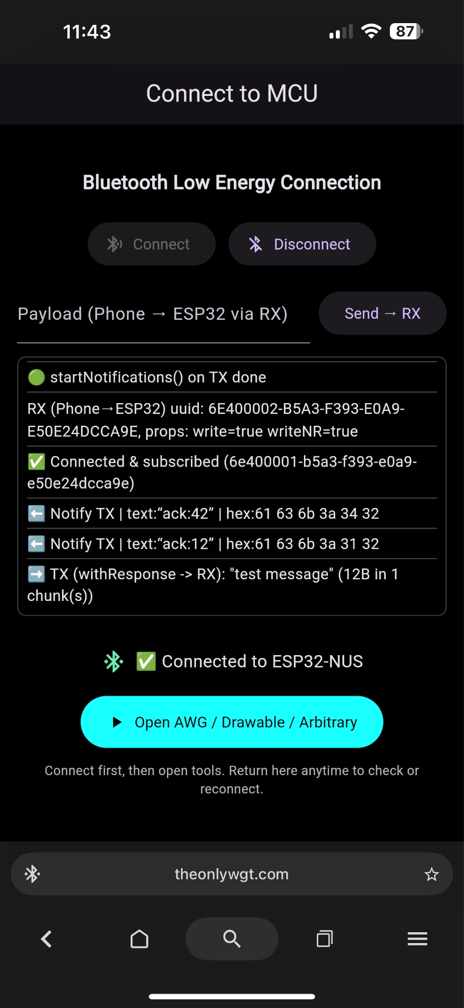
- Click the blue Open button to enter the app.
- Proceed to send data to the MCU using Packets
  - Basic waveforms send almost instantly
  - Arbitrary waveforms take ~2.5 minutes to send
  - 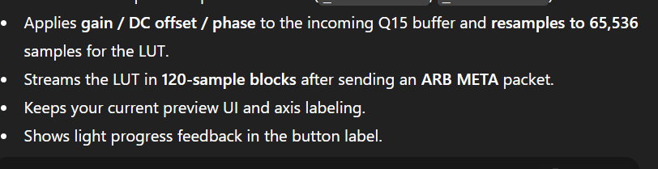

Notes for future Implementation:
- Improve speed ?
- Add download CSV function and check sent data makes the intended waveforms

Bugs Found:
Standard Waveforms
- Change Amplitude to VPP
- Change Amplitude range to 0-10
- Offset -5V to 5V
- Frequency change to Hz/KHz dropdown
- Add a phase slider from -180-180 degrees for standard waveforms.
- Reduce Y-Axis Scale to be -5 to 5
- Increase X-axis scale to be 0 to 100
- Remove Start Button
- Make graph larger on iphone

Arbitrary Waveform
- Fix Phase from -180 to 180 on Arb Editor
- 0 to positive time restrictions (throw an error, not a valid waveform (?))
- No negative values (1st and 4th Quadrant Only on drawable tab)
- Limit y scale to +=5 Volts
- Fix Drawable Tab Discontinuities
  - How to connect multiple waveforms when they end in different VPP
- Replace Drawable Tab to "Arbitrary" so there are only two tabs
- Limit Freq to 100kHz and Positive numbers
- Limit VPP to +5 and -5V

Overall Need to-Dos
- Fix CSV to download from phone to USB
- Change AWG to Func Generator
- Externally download points and rebuild to verify the correct waveform is being sent

Arduino Code
- Change Arduino Code to save CSV of points to check data sent
- Multiply data by Vpp and save to CSV easier

